Pamela Boyer Sayre, CG, CGl
Richard (Rick) G. Sayre, CG,CGL

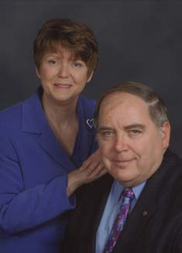
Pamela and Richard Sayre are professional researchers, educators, authors, and lecturers specializing in records in the Washington, DC area; Missouri, Western Pennsylvania; and Ohio. Pam & Rick develop, coordinate, and teach courses for University-affiliated programs in genealogy. And they lecture regularly at national and regional genealogy conferences across the United States. Pam is a fifth-generation Missourian by birth, and a new Mexican by upbringing. Rick was born and educated in Colorado, and during his thirty-one year Army career, he traveled the world.

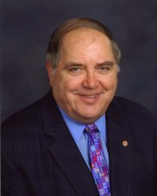
Rick coordinates the “Using Maps in Genealogy” course at the Institute of Genealogy and Historical Research at Samford University. He also instructs in the Advanced Methodology course, the Techniques and Technology course, the Advanced Military courses, and a variety of other IGHR courses. Rick and Pam coordinate the advanced land course and Researching in Washington, DC.

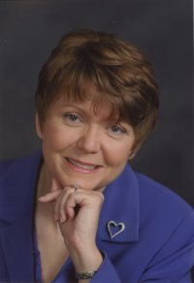
Pam has taught in Boston University’s Professional Certificate Program in Genealogy, and she developed an NGS self-paced Social Security course for family historians. Pam is First Vice President of the Utah Genealogical Association; former NGS director of education and publications; former board member of NGS and FGS; and is the co-author of Online Roots: How to Discover Your Family's History and Heritage with the Power of the Internet (2003) and Research in Missouri (1999, 2007).

